A1500-ASIA-Indus Valley-Miniature Bowl-Mehrgarh-Terracotta-3000 BCE

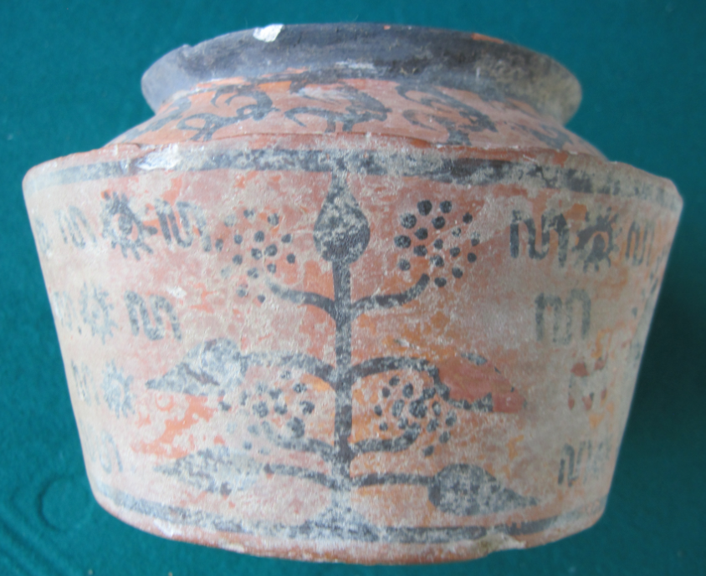

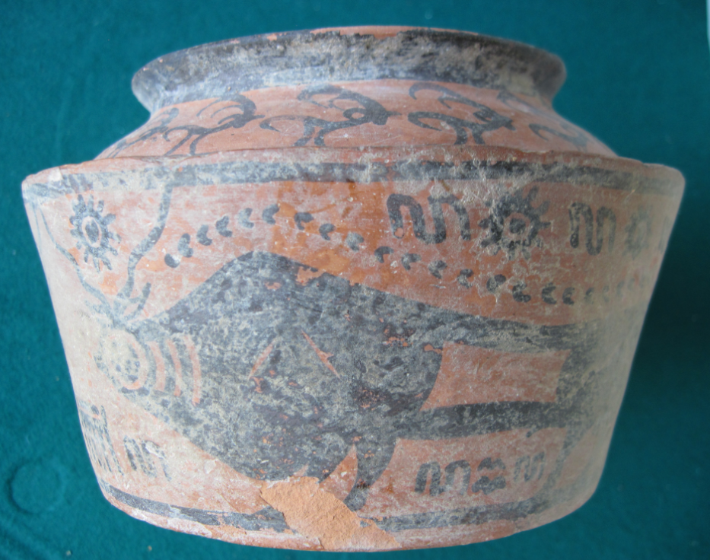

Figs. 1-2. Indus Valley-Figurine-Mehrgarh-Terracotta-3000 BCE

**Case no.: 3**

**Accession Number: A1500**

**Formal Label:** Indus valley-Figurine-Mehrgarh-Terracotta-3000 BCE

**Display Description:**

This Mohenjo-daro Pot flat base and a truncated body. The triple subjects are of a Horned Zebu bull, the pipal tree and the ibex. The pipal tree is presented as the structure of the ancient chackras of Hindu enlightenment philosophy. The zebu bull is a Hindu sacred animal. The ibex is the animal of the spirit, that bounds endlessly over the Indian plains and has its divine counterpart. This may have been a ritual object. It was not uncommon to have a large number of miniature pots buried with the body symbolic of religious ritual symbols to help the deceased in the journey to reincarnation.

The glyphs are presented to show the course of the zebu bull’s migration: water, birds and water suggest that the bull will find its way (the ungulate tracks above) to the water where the birds are. Water sun water sun also shows the way to the plains where there is a watering hole.

**LC Classification:** PK119

**Date or Time Horizon:** 3000-2500 BCE

**Geographical Area:** Mehrgarh

**Map, GPS coordinates: 29.38716 67.60955; 29º23'13.77" N 67º36'34.37" E**

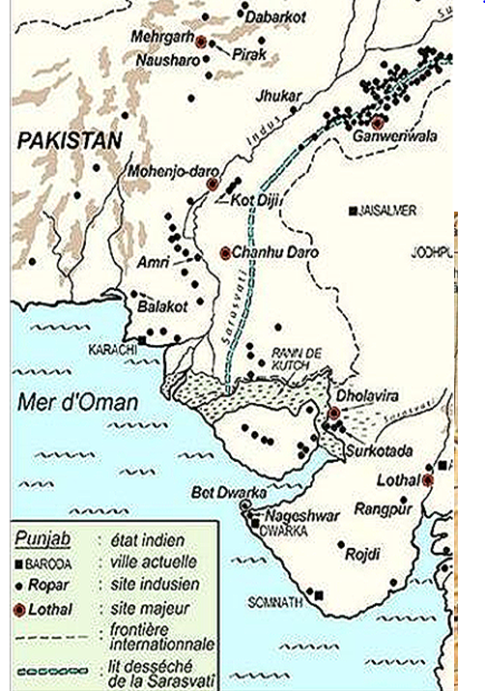

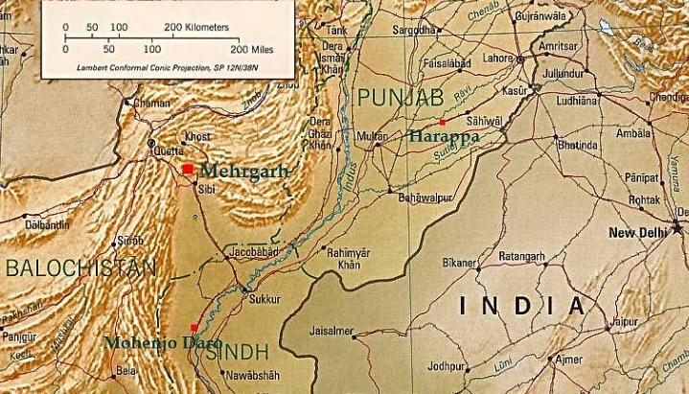

Figs. 2-3. Megharh in its geographical setting.

**Cultural Affiliation:** Indus

**Medium:** is red colored terracotta with the motifs encased within two bands top and bottom of the bowl.

**Dimensions:** H 74.66 mm; 119.83 mm top opening

**Weight:** 333 gm.

**Condition: original**

**Provenance:** Old European Collection

**Discussion:**

Mehrgarh was one of the oldest of the Indus Valley Civilization cities that was established ca 3000 BCE in the Indus and Ghaggar-Hakra river valleys (which is now Pakistan) and also northwest India and parts of Afghanistan and Turkmenistan. This Mehrgarh bowl has two symbolic Zebu bulls with curled horns, and a symbol between the horns signifying the locality it is destined to protect. It seems that the bulls are being led by a rope, separated by a palm tree. The Ibex are painted in black around the circumference with lines and scales below. This whole wheel-made bowl has a red slip painted over it internally and externally before the tan color and black design were painted over.

**References:**